PROGRAM
International Conference
«Respiratory Junction Almaty: Where East meets West»
as part of the annual forum "VI International Farabi Readings"

al-Farabi Kazakh National University
Faculty of Medicine and Healthcare
April 01 – 02, 2019
Venue: al-Farabi avenue 71, al-Farabi Library

The conference will be held in Almaty, Republic of Kazakhstan, al-Farabi avenue 71, al-Farabi Kazakh National University, al-Farabi Library
Goal
Bilateral knowledge translation between the leading experts from East and West on the most pertinent respiratory diseases.

Mission
To raise globally the standards of respiratory service by dialogue and knowledge translation on the state-of-the art advancements in diagnostics and therapy.

April 1
Registration 12.00-14.00
14.00-19.00 Plenary meeting: Respiratory Junction Almaty: Where East meets West
Moderators: Zhanna Kalmatayeva – Dean of the Faculty of Medicine and Healthcare of the al-Farabi Kazakh National University, Doctor of Science, Professor Associate (Kazakhstan)
Talgat Muminov - President of the Academy of Clinical and Fundamental Medicine of the Republic of Kazakhstan, Academician of RK, MD, Professor of the TB and pulmonology Department of the National Medical University (Kazakhstan)

14.00-14.15 | Opening | Zhanna Kalmatayeva - Dean of the Faculty of Medicine and Healthcare of the al-Farabi Kazakh National University, Doctor of Science, Professor Associate (Kazakhstan)  Tlekkabul Ramazanov -Vice-Rector for Scientific Innovation of al-Farabi Kazakh National University, Doctor of Science, Professor (Kazakhstan)  Representative of MES, MH
14.15-14.40 | The problem of COPD in Kazakhstan | Talgat Muminov -  President of the Academy of Clinical and Fundamental Medicine of the Republic of Kazakhstan, Academician of RK, MD, Professor of the TB and pulmonology Department of the National Medical University (Kazakhstan) | 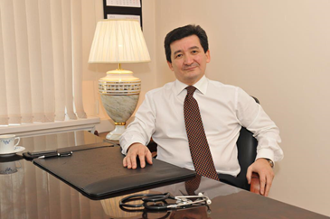
14.40-15.30 | Review of COPD in developed and developing countries | Claus Vogelmeier - MD, Doctor Habilitation, Chair of the Science Committee of the Global Initiative for Chronic Obstructive Lung Disease (GOLD), Director of the Clinic for Internal Medicine, Pulmonology, Intensive Care, and Sleep Medicine of the University Hospital Giessen and Marburg (location Marburg), member of the German Center for Pulmonary Research, Marburg (Germany) | 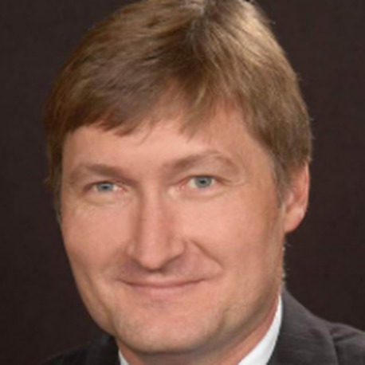
15.30-15.50 | Coffee break
16.00-16.25 | COPD as a controlled disease. Diseases management programs in Kazakhstan. | Roza Kuanyshbekova – Doctor of Science, Professor, Director of SRI of Cardiology and Internal Diseases of the MH RK (Kazakhstan)
16.25-16.50 | COPD as seen by general practitioners | Damilya Nugmanova – Doctor of Science, Professor, President of the Family Medicine Association of the Republic of Kazakhstan (Kazakhstan)
16.50-17.20 | Competences of general practitioner in COPD patients management | 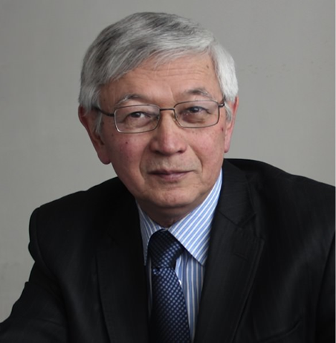 | Nurlan Brimkulov – Doctor of Science, Professor, Kyrgyz State Medical Academy after I.K. Akhunbaev (Kyrgyz Republic)
17.20-18.00 | The use of machine learning algorithms for the objective stratification of patients with COPD | Nurlan Dauletbayev – MD, PhD, researcher, respiratory specialist, specialist in personalized medicine, Professor at the Faculty of Medicine, McGill University; Montreal, Quebec (Canada) | 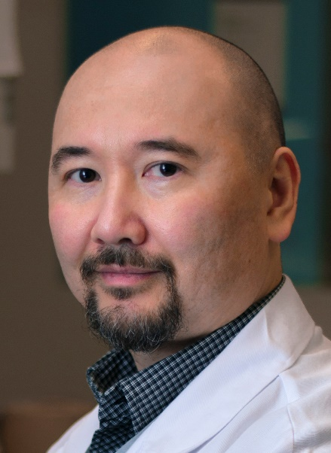
18.00-18.20 | Occupational COPD |  | Denis Vinnikov – Doctor of Science, Ph.D., Head of Environmental Health Laboratory, Faculty of Medicine and Healthcare of the al-Farabi Kazakh National University, ERS National Delegate – Kazakhstan (Kazakhstan)
18.20-18.40 | Diagnosis of alpha-1-antitrypsin deficiency in Kyrgyzstan and Kazakhstan | Salima Sydykova – PhD in medicine, assistant of the Department of family medicine (postgraduate education). Kyrgyz State Medical Academy after I.K. Akhunbaev, ERS Short-term Fellowship Program Fellow (Kyrgyz Republic)  Co-author Ardak Zhumagaliyeva - Head of the Department of Internal Medicine of the JSC “MUS”, PhD, ERS Short-term Fellowship Program Fellow (Kazakhstan) | 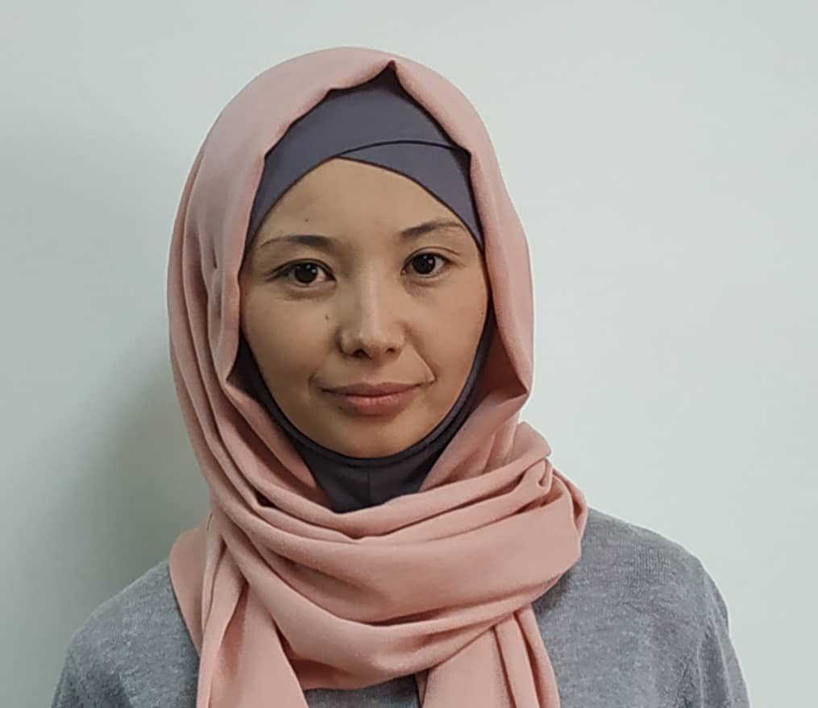
18.40 -19.00 | Discussion
April 2
14.00-16.30 | Sections
Moderators: Symbat Abzaliyeva - Candidate of Science, Deputy Director Higher School of Medicine of the Faculty of Medicine and Health Care, al-Farabi KazNU, Nurlan Brimkulov – Doctor of Science, Professor, Kyrgyz State Medical Academy after I.K. Akhunbaev

Topic 1 "What should be called COPD, severe bronchial asthma, or Asthma-COPD Overlap Syndrome (ACOS)”  Tair Nurpeisov - Doctor of Science, Professor, chief allergist of Almaty, head of the Republican Allergy Center (Kazakhstan) |  |  | 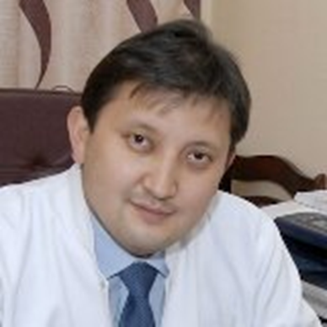
Topic 2. "Pneumonia or COPD exacerbation? Commonalities and differences in treatment strategies"

Gaukhar Kurmanova – Professor, Doctor of Science, al-Farabi Kazakh National University (Kazakhstan)
Topic 3. "Update on research in COPD"

Denis Vinnikov - Doctor of Science, PhD, Head of the Environmental Health Laboratory, Faculty of Medicine and Healthcare of the al-Farabi Kazakh National University (Kazakhstan)

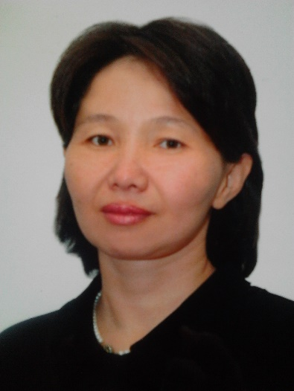 |  | «Effect indicators of COPD detection and treatment»  Gulstan Esetova – PhD in medicine, Head of the Department of Pneumology, NMU, Chief Pulmonologist of Almaty (Kazakhstan)
16.45-17.45 Round table
“The role of medical associations professional societies in the knowledge transfer between the leading experts from East and West on the most pertinent respiratory diseases”

Chairman - Talgat Muminov - President of the Academy of Clinical and Fundamental Medicine of the Republic of Kazakhstan, Academician of RK, MD, Professor of the TB and pulmonology Department of the National Medical University (Kazakhstan)
Resolution adoption

Our partners

